***TERM TWO WORK***

***Major resources in E.A***

Resources are things in the environment which people use to meet their needs.

***Examples of resources***

* Land
* Wind/air
* Minerals
* Water
* People
* Buildings
* Animals
* Vehicles

***Types of resources***

* Natural resources
* Man- made resources

***Natural resources***

These are things in the environment that exist on their own and can be used to meet people’s needs

***Types of natural resources***

* Renewable resources
* Non – renewable resources

***Renewable resources***

These are resource that can be replaced naturally once used up

They are also called ***inexhaustible resources***

***Examples of renewable resources***

* Land
* Water
* Wind
* People
* Animals
* The sun

***Nonrenewable resources***

These are things made by man that can be replaced naturally

***Examples of nonrenewable resources***

* Minerals

***Man-made resources***

These are the things made by man that can be used to meet people’s needs.

***Examples of man-made resources***

* Vehicles
* Buildings
* Telephones
* Money
* Furniture
* Clothes

***Land as a resource***

* Land is the part of the earth’s surface that is not covered by water.
* Land is regarded as the most important natural resource.

***Reasons why land is referred to as the most important natural resource.***

* Most of man’s activities are carried out on land.
* Most of other resources are found on land.

***Examples of resources found on land***

* Plants
* Animals
* Minerals
* People
* Water

***Uses of land***

* Land is used for settlement
* Land is used for crop growing
* Roads are constructed on land
* Industries are built on land
* People are buried on land
* Land is sold to get money

***Land degradation***

Land degradation is the lowering of the quality of land.

***Ways people degrade land.***

* By mulching land
* Through afforestation
* Through bush fallowing
* Through rotational grazing
* By terracing the land
* By contour ploughing
* By adding manure in soil to make it fertile.

***Land fragmentation***

This is the division of land into small plots

***Land fragmentation*** is common in districts like Kabale, Kisoro, Bududa, Sironko

***Causes of land fragmentation***

* High population
* Instalment buying and selling of land.

***Ways land fragmentation hinders agriculture***

* It hinders agricultural mechanization
* Crop pests can easily spread from one garden to another

Land fragmentation can be controlled through ***land consolidation.***

***Land consolidation*** is the process of joining small plots of land to form one big piece of land.

***Minerals as a resource***

Minerals are valuable substances found on or under the earth’s surface.

***Types of minerals***

* Metallic minerals
* Non metallic minerals
* Fuel minerals

***Metallic minerals***

These are minerals that can be melted to obtain new products

***Examples of metallic minerals***

* Copper
* Nickle
* Zinc
* Aluminum
* Iron ore
* Gold

Non metallic minerals

Thee are minerals that do not form new products when melted

***Examples of nonmetallic minerals***

* Phosphates
* Salt
* Sulphur
* Limestone
* Asbestos
* Soda ash

***Fuel minerals***

These are minerals that product heat or power when burnt

***Examples of fuel minerals***

* Crude oil
* Natural gas
* Coal
* Uranium

***Mining in East Africa***

Mining is the extraction from where they exist.

***A mineral deposit*** is an area where a given mineral is found in large quantities.

***An ore*** is a mineral in its raw ate.

***Examples of minerals mined in E.A***

|  |  |  |
| --- | --- | --- |
| ***Mineral*** | ***Mining area*** | ***Use*** |
| Gold | Karamoja, Busia, Kisumu, Kigoma, Mbeya, Mubende | It is used for making trophis, jewellery, oranments |
| Soda ash | Lake magadi | For making glass and soap |
| Copper | Kilembe in Kasese | For making electricity wires, copper coins and bullets |
| Diamond | Shinyanga (Mwadui) | For making drilling machines  For making jewellery |
| Salt | L. Katwe, L. Magadi | For making salt  For making animal feeds |
| Crude oil | Albertine region | For making petroleum products like petrol, diesel, kersonene, aviation fuel |
| Phosphates | Tororo | Used to make artificial fertilizers |
| Graphite | Gulu | For making pencil leads |
| Limestone | Hima, Osukuru hills, Kapchorwa | For making cement |
| Asbestos |  | For making iron sheets  For making pipes |

***Types of mining***

* Traditional mining – involves the use of simple tools.
* Modern mining – involves the use o modern equipment

***Methods of mining***

***Open cast mining***

This is the method of mining used to extract minerals near the earth’s surface.

This method is used to extract minerals like slat, soda ash, limestone

***Advantages of open cast mining***

* It is cheap
* It is not very risky for miners
* It requires less labour

***Disadvantages***

* It leads to land deformation
* It leads to displacement of people due to expansion

***Under-ground mining/shaft mining***

This method is used to extract minerals found deep underground.

* Minerals are extracted from deep underground by digging tunnels.
* This method of mining is very expensive

***Problems associated with underground mining***

* Mines collapse and kill people
* Suffocation of miners due to too much hat
* Mines can flood.

***Drilling method***

This method is used to extract minerals in liquid form

* Is used to extract minerals like crude oil and natural gas
* Minerals are extracted from underground from underground using long pipes
* The drills are supported by the machines called derricks.

***Oil mining in Uganda***

* Crude oil is oil in its natural form
* Crude oil in Uganda was discovered in the Albertine region
* Crude oil from the Albertine region will be transported by pipeline transport to Port Tanga on Tanzania for refining.
* An oil refinery is a place where crude oil is processed.
* Oil refineries in EA are found in Mombasa and Dar-es-salaam

***Examples of oil wells in the Albertine region***

* Kingfisher
* Ngege, Kingogole and Kasemene in Bulisa
* Mputa, Nzizi and Ngasa in Hoima
* Jobi and Lyec in Nwoya

**NB**: An oil well is a place where oil is found/got from.

***How Ugandans will benefit from oil mining in the Albertine region***

* They will get jobs
* They will get oil products
* It will lead to development of towns
* It will lead to development of infrastructure

***How oil mining has affected people in the Albertine region***

* Some people have been displaced
* It has caused pollution.

***Importance of the mining industry***

* Mining is a source of employment.
* Mining is a source of raw materials
* Mining is a source of income to the government
* Mining promotes the development of infrastructure.

***Factors considered before mining a mineral***

* Quantity of a mineral
* Market for the mineral
* Cost of extracting a mineral
* Transport

***Factors that have promoted the development of the mining industry***

* Availability of capital
* Availability of market for minerals for animals
* Presence of many mineral deposits
* Availability of labour
* Availability of reliable sources of energy

***Problems facing the mining industry in E.A***

* Lack of funds
* Low levels of technology
* Lack of skilled labour
* Unreliable power supply
* Insecurity in some areas

***Reasons why some minerals are not yet explained***

* Low technology
* Lack of funds
* Insecurity in some areas
* Some minerals appear in less quantities
* Poor transport in some areas.

***Problems associated with mining***

* Environmental pollution
* Mines can collapse and kill people
* Mining leads to land deformation
* Displacement of people from the mining areas
* It leads to devegetation

***NB***: The ministry of Energy and Mineral Development is responsible for mining in E.A

***Activity***

1. Why are plants called a resource?
2. State any one social importance of land.
3. Why are animals called renewable resources?
4. In which two ways can people misuse land?
5. In which two ways can people conserve land in hilly areas?
6. How can land fragmentation hinder agriculture?
7. What term is used to mean the joining of small plots of land to make a big piece of land?
8. Name the method of mining used to extract crude oil
9. Name the major mineral mined at Mwadui in Tanzania
10. Why will crude oil mined in the Albertine region be transported to Tanga port in Tanzania.
11. State any two disadvantages of open cast mining
12. What is an oil refinery?
13. Apart from crude oil, name any other mineral that can be mined by drilling methods.
14. Give two reasons why some minerals in E.A are not fully exploited.
15. Give two benefits of the mining industry to people.
16. Give two benefits of the mining industry to the government.

***Vegetation as a resource***

Vegetation is the plant cover of an area.

***Types of vegetation***

* Natural vegetation
* Planted vegetation

***Planted vegetation***

This is the plant cover of an area that is planted by man.

***Examples of planted vegetation***

* Planted forests
* Planted grass
* Flowers
* Crops

***Natural vegetation***

This is the plant cover of an area that grows on its owns.

***Examples of natural vegetation***

* Natural forests
* Shrubs
* Bushes
* Weeds
* Grasslands

***Types of natural vegetation***

* Savanna vegetation
* Equatorial vegetation
* Montane vegetation
* Semi desert vegetation
* Mangrove vegetation
* Swamp vegetation

***Map of E.A showing natural vegetation***

***Forest resources***

***A forest*** is a group of trees growing together.

***Forest resources*** are things got form forests that can be used o meet man’s needs.

***Forestry*** is the growing and caring of trees.

***Examples of forests resources***

* Timber
* Herbal medicine
* Wood fuel
* Latex
* Bark cloth
* Tannin

**NB:** Tannin is obtained from wattle trees and used in leather industries for softening leather.

* Latex is obtained from rubber trees for making products like car tyres, erasers gloves, condoms, shoe soles etc
* Bark cloth is obtained from ficus tree (mutuba)

***Types of forests***

* Natural forests
* Planted forests

***Natural forests***

These are groups of trees that grow on their own.

***Tree species in natural forests***

* Mahogany
* Green heart
* Mvule
* Teak
* Ebony
* Rose wood
* African walnut

***Characteristics of natural forests/Tropical rain forests***

* They are ever green
* They have thick undergrowth
* Trees grow very tall
* Trees have buttress roots
* Trees produce hard wood
* Trees are of different species
* Trees have broad leaves
* Trees form canopies

***NB: Trees in natural forests;***

* Grow tall to compete for sunlight
* Produce hard wood because they take long to mature
* Form canopies because they grow at different times
* Have buttress roots for extra support
* Have broad leaves to increase the rate of evaporation
* Are very green because trees shed leaves at different times of the year.

***Examples of natural forests in E.A***

***Uganda***

* Budongo (Largest)
* Mabira
* Malabigambo
* Maramagambo
* Bwindi
* Kibale
* Bugoma
* Zoka

***Kenya***

* Aberdare
* Karura
* Sokake
* Loita
* Bunyala
* Kakamega

***Tanzania***

* Rushosho
* Minziro
* Ngenzi
* Kimboza
* Champesha

***Rwanda***

* Mukura
* Buhaga
* Busaga
* Chamudongo

***Burundi***

* Baruli
* Kigwena
* Kibira
* Mututu

***Economic activities carried out in natural forests***

* Lumbering
* Charcoal burning
* Tourism
* Herbal medicine collection
* Hunting

***Planted forests***

These are groups of trees that are panted by man

***Tree species in planted forests***

* Pines
* Cypress
* Cedar
* Eucalyptus
* Spruce

***Characteristics of planted forests***

* Trees are planted in rows
* Trees are ell spaced
* Trees commonly produce soft wood
* Trees mature almost at the same day
* Trees are of the same species

**NB**: Trees in planted forests mature at the same time because they are planted at the same tie and trees and the same species

* Trees in planted forests are planted in rows for easy harvesting.

***Examples of planted forest in Uganda***

* Butamira (Jinja)
* Mafuga (Rukungiri)
* Bugamba (Mbarara)
* Nyabyeya (Masindi)
* Lendu (Nebbi) Largest
* Magamaga (Mayuge)

**Products obtained from soft wood**

* Match sticks
* Match boxes
* Papers
* Pencils
* Ply wood
* Wooden rulers
* Soft boards

***Mangrove vegetation/Mangrove forests***

These are forests that grow in shallow salty water along the coast of E.A

***Characteristic of mangrove forests***

* They produce hard wood
* They have buttress roots
* They are ever green
* They provide water proof timber

***Importance of mangrove vegetation***

* They provide hard and water proof timber for making water vessels.

***Importance of forests***

* They are sources of wood fuel e.g charcoal, firewood
* They help in rain formation
* They are habitants of wildlife
* They attract tourists who bring income
* Forests are sources of timber
* They are sources of herbal medicine
* Thy are sources of food to people and animals
* They help in controlling soil erosion

***Problems facing forests***

* Deforestation
* Outbreak of wild fires
* Encroachment by the people

***Deforestation***

This is the cutting down of trees on a large scale.

The cutting down of trees for timber is ***lumbering***.

***Reasons why people cut down trees***

* To get land for settlement
* To get land or farming
* To get land for road construction
* To get wood fuel
* To get timber

***Dangers of deforestation***

* It leads to soil erosion
* It leads to extinction of some tree species
* It leads to drought
* It destroys the habitats for wildlife

***Dangers associated with forests***

* They are breeding places for vectors
* Thy are hiding places for rebels
* They make road construction
* To get wood fuel
* To get timber

***Dangers of deforestation***

* They are breeding places for vectors
* They are hiding places for rebels
* They make road construction hard and costly

***Forest conservation***

This is the act of protecting forests from destruction

***National Forestry Authority*** is the body that conserves forests in Uganda

N.F.A is under the Ministry of Water and Environment.

**Roles of NFA**

* Teaches people the importance of forests
* Creates forests reserves
* Evicts people settling in forest
* Provides tree seedlings
* Enforcing laws against deforestation

***Ways of conserving forests***

* By practising re-afforestation
* By practising afforestation
* By practising agro forestry
* By educating people about the dangers of deforestation
* Through rural electrification

***Factors that influence the distribution of forests***

* Government policy
* Population distribution
* Nature of soils
* Altitude

***Activity***

1. Point out two examples of each of the following types of vegetation;
2. Natural vegetation
3. Planted vegetation
4. What type of natural vegetation grows in shallow salty water?
5. How does mangrove vegetation support the navigation industry?
6. Describe the wood obtained from mangrove vegetation.
7. Why do trees in planted forests commonly produce soft wood?
8. Why are trees in planted forests planted in lines?
9. Give one effect of competition for sunlight among trees in natural forests.
10. How does deforestation lead to soil erosion?
11. Name the ministry in Uganda in charge of protecting forests.
12. Name the type of medicine obtained from forests.
13. Why do trees in natural forests grow buttress roots?
14. Give two reasons why deforestation should be discouraged.
15. How does the nature of soil effect the distribution of forests?
16. How does rural electrification help to conserve forests?
17. Define the following;
18. Re-afforestation
19. Afforestation
20. Agro-forestry

***Swamp vegetation***

***A swamp*** is a water-logged area with vegetation.

Swamps are found along river, near lakes and in valleys

***Economic activities commonly carried out in swamps***

* Crop growing
* Fishing
* Mining
* Brick making

***Raw materials commonly obtained from swamps***

* Clay
* Palm leaves
* Reads
* Sand

**NB**: Ceramics are items made from clay.

***Importance of swamps***

* They ae fishing grounds
* They are sources of water
* They help in rain formation
* They are sources of raw materials to the crafts makers
* They help to filter water
* They are a habitant for aquatic animals.

**NB:**

* Crafts are handmade materials
* Examples of crafts are mats baskets, pots, doormats, ropes etc.

***Ways people misuse swamps***

* By dumping industrial wastes
* Though swamps drainage
* By burning vegetation in swamps

***Swamp drainage***

This is the removal if water from swamps

***Ways people drain swamps***

* By adding murram/soil in swamps
* By digging channels

***Reasons why people drain swamps***

* To get land for settlement
* O get land for road construction
* To get land for industrialization
* To get land for crop growing

***Dangers of draining swamps***

* It leads to drought
* It leads to death of aquatic animals
* It leads to floods

***Problems faced by people living near swamps***

* Floods during heavy rains
* Attacks from aquatic animals
* Attacks from disease vectors

***NB:***

* National Environment Management Authority (NEMA) is the body responsible for protecting swamps.

***Duties of NEMA***

* Teaches people the importance of swamps
* Evicts people on have settled in swamps
* Enforcing laws against swamp drainage
* To assess the impact of different activities on the environment.
* Helps in making environment laws

***Montane vegetation***

* This is the type of natural vegetation that grows on slopes of high mountains
* There are varying vegetation zones on mountain slopes due to differences in altitude
* Altitude is the major factor that influences vegetation distribution on a mountain slope.

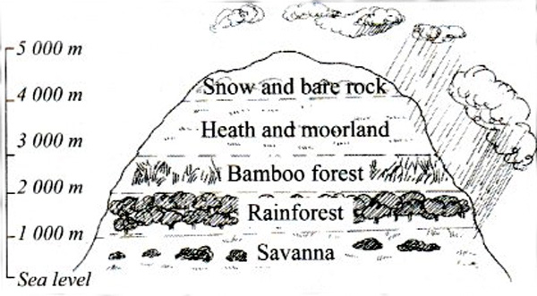

* Montane vegetation is found on slopes of high mountains like Rwenzori, Kilimajaro, Kenya, Elgon, Mufumbiro, Longonot etc
* Mountain gorillos live in bamboo vegetation zone because they feed on young bamboo plants.
* Thick vegetation commonly grows on the wind ward side of the mountain because of reliable rainfall receive.
* There is no vegetation at the top of the mountain due to very low temperatures

***Semi desert vegetation***

* It grows in semi desert area
* It is commonly found in Northeastern Uganda and Northern Kenya

***Characteristics***

* Trees have thick barks to store water
* Trees are thorny to reduce the rate of transportation
* Trees have long top roots to absorb water from underground
* Trees have tiny leaves to reduce the rate to transpiration

***Economic activities in semi desert vegetation***

* Bee keeping
* Pastoralism/Animal keeping

***Savanna vegetation***

This is the type of natural vegetation that grows in most parts of E.A

It is found in areas that experience tropical climate

***Groups of savanna***

* Savanna grassland – It has mainly tall grass
* Savanna woodland – It has tall grass and many trees

***NB:***

* An example of savanna woodland in Miombo woodlands in Tanzania
* Human settlement and live stocking farming is limited in Miombo woodlands due to many tsetse flies
* The major economic activity in the Miombo woodland is bee keeping

***Characteristics of savanna vegetation***

* It has tall grass
* It has scattered trees
* It has deciduous tree
* Trees have long tap roots to absorb water from deep underground.

***NB:***

* Deciduous trees are trees that shed leaves during the dry season.
* Trees shed leaves in the dry season to reduce the rate of transpiration.
* Most game parks in E.A are located in Savanna because has a complete food chain for wildlife.

***Major economic activities under different types of natural vegetation***

* Tropical rain forests – lumbering
* Savanna – tourism
* Semi desert – cattle keeping

**Importance of vegetation**

* It is a source of food to people and animals
* It helps in rain formation
* It is a source of herbal medicine
* It controls soil erosion
* It is a source of wood fuel
* It attracts tourists who bring income
* It acts as a habitat for wildlife
* It purifies air by absorbing carbon dioxide and releasing oxygen

***Dangers of vegetation***

* Vegetation is a breeding place for some disease vectors
* Vegetation is a hiding place for bad people
* Vegetation makes road construction hard and costly
* Vegetation is a habitat for dangerous wild animals

***Factors that influence vegetation distribution***

***Nature of soils***

* Areas with fertile soils have thick vegetation
* Areas with poor soils have scanty vegetation

***Rainfall distribution***

* Areas that receive heavy rainfall have thick vegetation
* Areas that receive little altitude or no rain have scanty vegetation

***Altitude***

* Areas of low altitude have thick vegetation
* Areas of very high altitude have no vegetation due to too much coldness.

***Government policy***

* The government sets aside and protects forests and forest reserves.

***Human activities***

* Some human activities support the growth of vegetation while others destroy vegetation.

***Human activities that support the growth of vegetation***

* Afforestation
* Re-afforestation
* Rotational grazing
* Agroforestry
* Swamp conservation

***Human activities that destroy vegetation***

* Road construction
* Charcoal burning
* Brick making
* Lumbering

***Effects of destroying vegetation***

* It leads to drought
* It leads to soil erosion
* It leads to global warming
* It leads to land degradation

***Activity***

1. Why is it dangerous for people to settle near swamps?
2. Which types of rainfall is received in areas near large swamps?
3. What are crafts?
4. Mention any craft materials children use at school to play
5. Why is there changing vegetation zones on mountain slopes?
6. Why do trees in semi desert areas grow tiny leaves?
7. What major factor influences vegetation distribution on a mountain slope?
8. Why doesn’t the leeward side of the mountain have thick vegetation?
9. Give an example of a wooded savanna in E.A.
10. In which one way people drain swamps?
11. Why are yams commonly grown in swamps?
12. In which two ways does NEMA conserve swamps?
13. State any two examples of wood fuel.
14. How does vegetation modify climate?
15. Why are the miombo woodlands of Tanzania sparsely populated?

***Animals as a resource***

***Types of animals***

* Domestic animals
* Wild animals

***Domestic animals***

These are animals kept at home

***Examples of domestic animals***

* Rabbit
* Goat
* Pig
* Cattle
* Sheep
* Donkeys
* Camel

***Importance of keeping domestic animals***

* They are sources of income when sold
* Some provide milk
* Some provide security
* Some are used for ploughing
* Some provide meat
* Some domestic animals are used for transport
* Some domestic animals are used for paying bride price.

***Reasons why some people don’t keep domestic animals***

* They are expensive to buy
* Some people lack land
* Some religious beliefs forbid people from keeping some animals
* They are costly to look after

***Wild animals***

These are animals which live on their own in the environment

***Examples of wild animals.***

* Lion, elephant, zebra, giraffe, leopard, snake etc

***Types of wild animals***

***Carnivorous animals*** – These are fresh eating animals e.g. lions, leopards, tigers etc

***Herbivorous animals*** – These feed on vegetation e.g antelopes, zebras, elephants, hippos etc

***Omnivorous animals*** – These feds on both flesh and vegetation eg gorillas, monkeys, baboons, apes etc

***Wildlife in E***.***A***

***Wildlife*** are birds, animals, plants and insects that live on their own in the natural habitat.

***Uganda Wildlife Authority (UWA)*** is responsible for conserving wildlife in Uganda.

***Place where wildlife is conserved in E.A***

* National parks
* Game reserves
* Sanctuaries
* Marine parks
* Zoos (where animals are kept in cages for public viewing)

***Examples of wildlife***

* Flamingo birds
* Mountain gorillas
* Crocodiles
* Warthogs
* Cheetah
* Ostriches

***National parks in E.A***

* A national park is an area set aside by the government to conserve wildlife

***Examples of National Parks in Uganda***

* Murchison Falls NP – Largest in Uganda
* Queen Elizabeth NP
* Kidepo valley National Park
* Kibaale National Park
* Mgahinga National Park
* L. Mburo National Park
* Mount Rwenzori National Park
* Semliki National Park
* Bwindi National Park
* Mt. Elgon National Park

***Examples of National Parks in Tanzania***

* Tsavo National Park – Largest in Kenya
* Aberdare National Park
* Longonot National Park
* Lake Nakuru National Park
* Malka Mari National Park
* Mt. Kenya National Park
* Lake Amboseli National Park
* SIbiloi National Park

***Examples of National Parks in Tanzania***

* Great Ruaha National Park – Largest in Tanzania and E.A
* Serengeti National Park
* Kilimanjaro National Park
* Mikumi National Pak
* Katavi National Park
* Tarangire National Park
* Mahale National Park

***National parks in Rwanda***

* Akagera N.P
* Volcano N.P
* Nyungwe forest N.P

***National parks in Burundi***

* Ruvubu National Park – Largest in Burundi
* Kibira National park

***Map showing national parks in E.A***

***Key***

1. Kidepo Valley N.P
2. Murchison falls N.P
3. Mt. Elgon N.P
4. Mt. Rwenzori N.P
5. Queen Elizabeth N.P
6. Make Mburo N.P
7. Bwindi N.P
8. Vocano N.P
9. Akagera N.P
10. Nyungwe forest N.P
11. Ruvubu N.P
12. Kibira N.P
13. Malka Mari N.P
14. Sibiloi N.P
15. Mt. Kenya N.P
16. Aberdare N.P
17. Amboseli N.P
18. Tsavo N.P
19. Serengeti N.P
20. Trangire N.P
21. Mahale N.P
22. Katavi N.P
23. Great Ruaha N.P
24. Mikumi N.P
25. Uzungwa N.P

***Major tourist attractions in some game parks***

|  |  |
| --- | --- |
| ***National park*** | ***Tourist attraction*** |
| Murchison falls N.P  Queen Elizabeth N.P  Kidepo valley N.P  Lake Mburo N.P  Mgahinga & Bwindi N.P  Tsavo N.P  Lake Nakuru N.P  Serengeti N.P | Crocodiles, Murchison falls  Hippopotamuses  Ostriches  Zebras  Mountain gorillas  Lions  Flamingo birds  Wild beats |

***Game reserves***

***A game reserve*** is an area set aside by the government for future development into a national park.

***Hunting*** in game reserves is allowed with permission

***Examples of game reserves***

***Uganda***

* Pian-Upe
* Bokora
* Matheniko
* Katonga
* Tooro
* Ajai
* Kyambura

***Tanzania***

* Mkomazi
* Selous
* Ugalla
* Ngorongoro

***Kenya***

* Masai Mara
* Samburu
* Bururi
* South Kituli

***Rwanda*** – Gishwati forest

***Burundi*** – Kigwena, Makamba

***Importance of national parks***

* They are sources of employment
* They attract tourists who bring income
* They promote the development of infrastructure
* They help to conserve wildlife
* They are used for research and study purpose

***Activities that commonly take place in N.P***

* Animal tracking
* Mountain climbing
* Game drives
* Boat rides

***Prohibited activities in N.P***

* Animal grazing
* Crop cultivation
* Hunting
* Human settlement

***Problems facing national parks***

* Poaching
* Human encroachment
* Wildlife diseases which kill wildlife
* Wild bush fires which lead to death of wildlife
* Drought which leads to lack of water and pasture

***Poaching***

This is the illegal hunting of wildlife in National parks

***Why people carry out poaching***

* To get meat
* To get hides and sins
* To sell animal products and get money
* To get horns and ivory

***Dangers of poaching***

* It leads to extinction of some animal species
* It reduces the number of animals in national parks

***Solutions to problems facing national parks***

* Enforcing strict laws against poaching
* Teaching people about the importance of wildlife
* Improving security in National Park areas
* Evicting encroachers
* Providing more veterinary doctors to treat the animals

***Ways of caring of animals***

* Protecting them from poachers
* Feeding them
* Treating sick animals
* Conserving their habitats

***Note:***

***A game warden*** is a person in charge of a national park.

***A game ranger*** is a person who protects wildlife in a national park.

***Sanctuaries***

A sanctuary is an area set aside for conserving endangered species of wildlife.

***Examples of sanctuaries***

* Ngamba Island sanctuary for chimpanzees
* Lake Nakuru for flamingo birds
* Ziwa Rhiona sanctuary

***Activity***

1. Give two examples of pack animals
2. Give two examples of omnivorous animals
3. Why are national parks called so?
4. What major tourist attraction is found at Kidepo N.P?
5. State any one difference between a national park and a game reserve.
6. How is poaching a dangerous activity to National Parks?
7. Give two reasons why wild animals should be protected.
8. Why is human settlement in National parks prohibited?
9. Name the largest national park in E.A.
10. What role is played by game rangers in national parks?
11. How do national parks promote the development of infrastructure?
12. How can the government of Uganda control poaching in National parks?
13. Why are veterinary doctors needed in game parks?
14. Name the body in Uganda responsible for conserving wildlife.
15. Which national park in E.A is famous for wild beasts?

***Tourism industry in E.A***

Tourism is the business of providing services to the tourists

* Touring is the movement or people to places of interest for pleasure or study purposes.
* A tourist is a person who travels to places of interest or study purposes.

***Types of tourists***

* Local/domestic tourists – move from one part of the country to another.
* Foreign/international tourists – move from one country to another.

***Services provided to tourists***

* Accommodation
* Meals
* Recreation
* Communication
* Transport
* Security

***Why tourism is called***

1. An industry

It is a source of income

It is a source of employment

1. ***An invisible trade***

Tourism earns income but no physical goods are exchanges

1. ***An invisible export***

Tourism earns income but no physical goods are exchanged across borders.

***Other examples of invisible exports***

* Electricity
* Education
* Technology

***Factors that promote tourism***

* Good transport network
* Good communication network
* Improved security
* Good communication
* Presence of many tourists attractions

***Tourist attractions in E.A***

* Wild life
* Physical features
* Vegetation
* Beautiful beaches
* Culture
* Climate
* Historical sites

***Importance of tourism***

* It is a source of employment
* It promotes development of infrastructure
* It provides market for local products
* It is a source of government revenue
* It promotes the conservation of wildlife

***Problems facing the tourism industry***

* Poor transport network
* Poor accommodation services
* Insecurity in some areas
* Lack of funds
* Limited tourists attractions
* Outbreak of epidemics like COVID19

***Dangers caused by tourism***

* Some tourists come as spies
* It can lead to spread of diseases in the country
* Some tourists teach people anti-social behavior

***Why Kenya’s tourism industry is more developed than that of Uganda***

* Kenya has more tourist attractions than Uganda
* Kenya has better accommodation facilities than Uganda
* Kenya advertises her tourist attractions more than Uganda

***Climate as a resource***

***Weather*** is the state of the atmosphere of a place at a given time.

***Meteorology*** is the scientific study of weather

***A meteorologist is*** a person who studies weather

***A weather station*** is a place where elements of weather are studied and recorded.

***The biggest meteorological centre/weather station is found at Entebbe***

***Weather forecasting*** is the telling of future weather changes

***Importance of weather forecasting***

* It helps farmers to plan for farm activities
* It helps travelers to plan for their journeys
* It helps pilots to plan for their flights
* It helps school going children to know what to put on

***Main aspects of climate***

* Rainfall
* Temperature

***Types and conditions of weather***

***Types and conditions of weather***

|  |  |
| --- | --- |
| Element/factor | Condition/type |
| Rainfall  Cloud cover  Wind  Sunshine  Fog  Mist  Temperature  Air pressure  Humidity | Rainy  Cloudy  Windy  Sunny  Fogy  Misty  Hot/cold earth  Low/high pressure  Humid |

***Weather instruments and their importance***

***Diagrams for weather instruments***

|  |  |  |
| --- | --- | --- |
|  |  |  |
| ***Wind vane*** | ***Windsock*** | ***Anemometer*** |
|  |  |  |
| ***Barometer*** | ***Rain gauge*** | ***Sunshine recorder*** |
|  |  |
| ***Hygrometer*** | ***Six’s thermometer*** |

|  |  |
| --- | --- |
| ***Weather instrument*** | ***Use*** |
| Anemometer  Wind vane  Rain gauge  Sunshine recorder  Hygrometer  Barometer  Six’s thermometer  Windsock | * Measures the speed wind * Shows the direction of wind * Measures the amount of r/fall received * Shows the hours the sun has shone in a day * Measures humidity * Measures air pressure * Temperature of a place * Shows strength of wind |

***Delicate weather instruments***

* Hygrometer
* Six’s thermometer
* Barometer

***A Stevenson screen***

* This is a structure at a weather station where delicate weather instruments are kept.
* A Stevenson screen is built with louvers to allow free air circulation.
* It is pointed white to reflect heat
* It is made of wood because wood is a poor conductor of heat
* It has metallic stand to prevent termites from destroying them.



***Note***:

***Rainfall*** is *measured in millimetres to know how deep rain water enters the ground.*

***Terms related to different elements of weather***

* Contours are lines drown on a weather map to show places with same altitude
* Isohyets are lines drawn on a weather map to show places with the same amount of rainfall.
* Isobars are lines drawn on a weather map to show places with the same air pressure.
* Isotherms are lines drawn on a weather map to show places with same amount of sunshine.
* Isonephs are lines drawn on a weather map to show places with the same cloud cover.

***Importance of different elements of weather***

***Wind***

Wind is moving air/air in motion

***Importance of wind***

* Wind helps in rain formation
* Wind helps in winnowing
* Wind helps in driving some boats
* Wind drives away bad smell
* Wind helps in pollination
* Wind is used to fly kites
* Wind is used to turn wind mills

***Dangers of wind***

* Strong winds can blow off the roofs of houses
* Wind causes soil erosion
* Strong wind can force boats to capsize
* Wind pollutes the atmosphere by raising dust
* Wind spreads diseases

***Rainfall***

This is the amount of rain received in a given area

***Rain*** is the main natural source of water

***Types of rainfall***

***Convectional rainfall***

It is commonly received in forested areas and areas near large water bodies

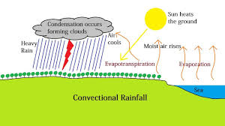

***Cyclonic rainfall***

* It is also called frontal rainfall.
* It is commonly received in flat/plain areas
* The meeting point for cold air and warm air is called a front

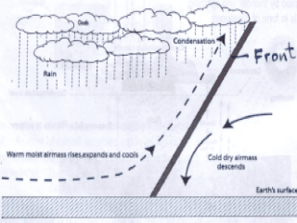

***Relief rainfall***

* It is also called orographic rainfall
* It is commonly received in hilly/mountainous/highlands areas

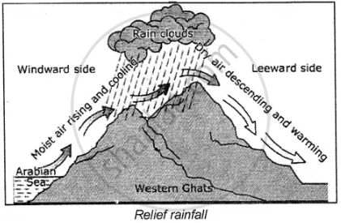

* The wind ward side of the mountain is the side of the mountain that receives rainfall because it receives warm most wind/air.
* The lee ward or rain shadow is the side of the mountain that does not receive rainfall because it receives dry wind/air.

***Processes involved in rain formation***

* Evaporation (water bodies)
* Transpiration (vegetation)
* Condensation

***Importance of rainfall***

* It provides water for domestic use
* It provides water to plants to grow
* Rainfall cools the environment
* It softens the soil for easy cultivation
* It reduces dust

***Dangers of rainfall***

* It leads to soil erosion
* To much rainfall causes floods
* Too much rainfall causes landslides
* It makes murram roads muddy and slippery
* Heavy rainfall destroys farmers’ crops

***Sunshine***

* The main natural source of light is the sun.
* E.A receives enough sunshine because it lies near/across the equator
* Sunshine is tapped and used by people as solar energy.

***Importance of sunshine***

* It dries harvested crops
* It provides light
* It is a source of vitamin D.
* It dries wet clothes
* It helps in generation of solar energy

***Solar energy projects in Uganda***

* Tororo solar plant
* Soroti solar plant
* Kabulasoke solar plant (Gomba)

***Dangers of sunshine***

* Strong sunshine leads to drought
* It dries up water bodies
* It dries pasture for animals
* It causes dust
* It dries up crops in gardens before maturing

***Cloud cover***

These re solid drops of rain in the atmosphere.

***Importance of clouds***

* They protect us from direct sun rays
* Some clouds like nimbus clouds give us rain
* They keep the earth warm at night

***Weather disasters***

These are severe weather changes that cause great damage.

***A disaster*** is an unplanned happening that causes great damage.

***Examples of weather disasters***

* Floods
* Landslides
* Drought
* Storms
* Lightning
* Hailstorms

**Floods**

This is when an area that has been dry is filled with water

***Causes of floods***

* Too much rainfall
* Poor drainage
* Swamp drainage

***Effects of floods***

* They displace people
* They destroy property
* They destroy crops
* They kill people

***Ways of controlling floods***

* They displace people
* They destroy property
* They destroy crops
* They kill people

***Ways of controlling floods***

* Constructing drainage channels
* Conserving swamps

***Drought***

This is a long period of sunshine

***Causes of drought***

* Deforestation
* Swamp drainage
* Industrialization
* Bush burning

***Effects of drought***

* Dries up water bodies
* Dries up pasture for animals

***Landslides***

* Caused by too much rainfall
* Caused by deforestation

***Effects of landslides***

* Displacement of people
* Destruction of property
* They kill people

***Ways of controlling land slides***

* Conserving vegetation on mountain slopes
* Avoiding settlement on mountain slopes

***Activity***

1. State the two major aspects of climate
2. In which district is the largest meteorological station in Uganda?
3. Why is a six’s thermometer kept in a Stevenson screen?
4. How is weather forecasting important to a P.6 pupil?
5. Why is rainfall measured in millimetres?
6. Give a reason why a rain gauge should be placed in an open area.
7. Give a reason why a Stevenson screen is painted white
8. Which type of rainfall is commonly received in plateau areas?
9. What is a front?
10. State any to ways landslides victims can be helped.
11. In which two ways is rainfall a danger?
12. What role is played by the mountain during the formation of relief rainfall?
13. State any one danger of hailstorms.
14. State any one advantage of solar energy over H.E.P.
15. Mention any two districts in Uganda commonly affected by landslides.
16. How is a sunshine recorder important?
17. How does drought affect livestock farmers?
18. State one-way clouds are important.

**Climatic regions of E.A**

* Climate is the average weather conditions of a place studied and recorded for a long time.
* Climatology is the scientific study of climate
* A climatic region is a large area that experiences the same type of climate.

***The climatic regions of E.A include***

* Equatorial climate
* Tropical climate
* Semi-desert climate
* Montane climate

***Map of E.A showing climatic regions***

***Equatorial climate***

* It is described as hot and wet throughout the year
* It is experienced in areas near the equator
* In E.A it is commonly experienced in areas around L. Victoria.

Characteristics of Equatorial climate

* Temperatures are high throughout the year
* Rainfall is received throughout the year
* It has a double maximum of rainfall (two seasons of heavy rainfall brought about by the two equinoxes)
* Convectional rainfall is commonly received.

***Common economic activities in Equatorial climate***

* Crop growing
* Lumbering
* Tourism
* The major economic activity in this climatic region is crop growing
* Crops mainly grown are perennial crops like sugarcane, tea, oil pam, cocoa, rubber trees etc.
* People living in equatorial areas build houses with slanting roofs to allow easy flow of rain water off the roofs.

***Climate table for Equatorial climate***

|  |  |  |  |  |  |  |  |  |  |  |  |  |
| --- | --- | --- | --- | --- | --- | --- | --- | --- | --- | --- | --- | --- |
| Months | J | F | M | A | M | J | J | A | S | O | N | D |
| Temp. (oC) | 27 | 27 | 27 | 26 | 25 | 25 | 25 | 26 | 27 | 27 | 26 | 26 |
| R/fall(mm) | 70 | 80 | 150 | 220 | 130 | 130 | 75 | 75 | 75 | 220 | 125 | 125 |

***Climate graph for equatorial climate***

***Tropical climate***

* It is described as wet and dry.
* It is experienced in most parts of E.A because most parts of E.A are in the tropical region.
* The tropical region is an area between the tropic of cancer and tropic of Capricorn.

Characteristics of tropical climate

* It has one wet season and on dry seasons
* They dry season is shorter than the wet season
* Heavy rainfall is received when the sun is overhead the equator.

***Economic activities in Tropical climate***

* Tourism
* Be keeping
* Pastoralism
* Crop growing

***Climatic table for tropical climate***

|  |  |  |  |  |  |  |  |  |  |  |  |  |
| --- | --- | --- | --- | --- | --- | --- | --- | --- | --- | --- | --- | --- |
| Months | J | F | M | A | M | J | J | A | S | O | N | D |
| Temp. (oC) | 24 | 23 | 22 | 21 | 21 | 18 | 17 | 18 | 20 | 23 | 24 | 24 |
| R/fall(mm) | 200 | 175 | 100 | 25 | 20 | - | - | - | - | 50 | 100 | 174 |

***Semi desert climate***

* It is described as hot and dry
* It is experienced in Northeastern Uganda and Northern Kenya

***Characteristics of semi desert climate***

* Very little rainfall is received
* Temperatures are high
* Dry season is longer than the wet season

***NB:***

* The major economic activity carried out in semi desert climate is pastoralism or cattle keeping.
* Crop farming can be made possible in semi desert areas through irrigation.

***Montane climate***

* It is experienced I highland areas
* It is experienced around mountains like Elgon, Kilimajaro, Kenya, Rwenzori, Mufumbiro etc
* The wind war side receives more rainfall than the lee ward side.

***Factors that influence the climate of E.A***

***Altitude***

* This is the height above sea level.
* Areas at a high altitude are cold.
* Areas at a low altitude are hot/warm

***Latitude***

* Latitude is the distance North or South of the equator
* Areas near the equator are hot
* Areas far from the equator are cold
* Areas near the equator receive more rainfall

***NB***:

* Areas near the equator are hot because they receive direct sun rays
* Areas near the equator are hot.
* Areas far from the equator are cold.
* Areas near the equator receive more rainfall due to the high rate of transpiration and evaporation because of the high temperatures.

***Distance from large water bodies***

* Areas near large water bodies receive more rainfall due to the high rate of evaporation

***Vegetation cover***

* Aras with thick vegetation receive heavy rainfall.
* Areas with scanty vegetation receive little or no rainfall.

***Prevailing winds***

* These are winds that blow to a particular direction throughout the year.
* The climate of E.A is influenced by both warm prevailing winds and dry prevailing winds
* South East Trade winds are the warm moist prevailing winds that bring rainfall to E.A
* North East prevailing winds are the winds that cause dry conditions in Northeastern Uganda and Northern Kenya.

***Note:***

* Warm prevailing winds cause rainfall while dry prevailing winds cause dry conditions

***Human activities***

* Human activities that influence climate positively help in rain formation and these include;
* Agro-forestry
* Afforestation
* Re-afforestation
* Swamp conservation
* Human activities that influence climate negatively reduce the amount of rainfall received and they include.
* Lumbering
* Charcoal burning
* Industrialization
* Brick making

***Influence of climate on;***

***People’s activities***

* People living in equatorial areas mainly grow perennial crops
* People living in semi desert areas carry out cattle keeping

***Nature of building***

* People living in Equatorial areas build houses with slanting roofs.
* People living in dry areas build houses with flat roofs.

***Vegetation cover***

* Equatorial climatic zones have thick vegetation cover
* Semi desert climatic zones have scanty vegetation

***Way of dressing***

* People living in cold areas put on heavy clothes
* People living in hot areas put on light clothes

***Climate change***

Climate change is the long-time variation of the weather pattens of an area.

***Indicators of climate change***

* Too much rainfall
* Prolonged drought
* Decrease in temperature
* Increase in temperature
* Floods
* Storms
* Melting of snow

***Causes of climate change***

* Deforestation
* Swamp drainage
* Industrialization
* Bush burning
* Afforestation
* Re-afforestation

***Results of climate change***

* Drying of water bodies
* Too much dust
* Lack of pasture for animals
* Death of people and animals
* Melting of snow on mountain peaks
* Famine
* Reduction in the amount of rainfall

***Global warming***

This is the constant rise of world temperatures

* It is mainly caused by the releasing of greenhouse gases to the atmosphere.

***Examples of greenhouse gases***

* Carbon dioxide
* Carbon monoxide

***Note***:

* Global warming takes place when the ozone layer is destroyed.
* The ozone layer is a later of gases that protect the earth from strong sunrays.

***Effects of global warming***

* Acidic rains
* Melting of snow on mountain peaks
* Increase in temperatures
* Drought
* Reduction in the amount of rainfall received
* Dry up of water bodies

***Ways of controlling/reducing global warming***

* By planting trees
* By conserving swamps
* By treating industrial fumes before release
* By enforcing law that protect the environment.

***Activity***

1. What type of climate is experienced in areas close to the equator?
2. Give a reason why areas near the equator are ho?
3. What name is given to an area between the Tropic of Cancer and the Tropic of Capricorn?
4. Describe semi desert climate
5. Why do people in equatorial regions build houses with slanting roofs?
6. How does altitude influence climate?
7. What type of climate is experienced in most parts of E.A?
8. How does climate influence the way people dressing?
9. What term is sued to mean the long tie variation of weather patterns of an area?
10. How do the North East trade winds influence the climate of E.A?
11. How do warm prevailing winds influence the climate of E.A?
12. What type of climate is experienced in Northern Kenya?
13. State nay two indicators of climate change
14. State any two causes of global warming
15. Why is Kabale cooler than Soroti?

***Crop growing in E.A***

***Cultivation*** is the growing of crops for commercial use or home use.

***Crops*** are plants that are grown by people for food or sale.

***Types of crops***

* Traditional cash crops
* Non-traditional crops

***Non-traditional cash crops***

These are crops that are grown for both food and for sale.

***Examples of non- traditional cash crops***

* Bananas
* Beans
* Maize
* Millet
* Sorghum
* Cassava
* Soya beans
* Cow peas

***Reasons why people grow non traditional cash crops***

* To promote food security
* To sell crops and get money
* To get raw materials for agro-based industries

***Traditional cash crops***

These are crops that were introduced long ago to be grown for sale.

***Examples of traditional cash crops***

* Coffee
* Cotton
* Tobacco
* Cocoa
* Sugarcane
* Tea
* Pyrethrum
* Cloves
* sisal

***Importance of growing traditional cash crops***

* They are sold to get money
* They are a source of raw materials to agro based industries
* They are a source of employment

***Types of farming***

***Arable framing :*** This is the growing of crops

***Livestock farming :*** This is the rearing of farm animals

***Systems of arable farming***

* Subsistence farming
* Plantation farming
* Mixed farming

***Subsistence farming***

* This is the growing of crops and rearing of animals for home use and surplus for sale.
* This is the system of farming carried out by most people in E.A because it is cheap to carryout.
* Annual crops are commonly grown by subsistence farmers.
* Annual crops are crops that take less than a year to mature.

***Advantages of subsistence farming***

* It requires less capital
* It requires less land
* Simple tools can be used
* It requires less labour

***Disadvantages***

* Less income is earned by farmers
* Low yields are obtained

***Plantation farming***

* This is the growing of one perennial crop on a large scale for sale.
* Individual farmers who grow crops similar to those on plantation farms rare called out growers.
* It is also called estate farming.
* Perennial crops are crops which are harvested year after year.
* Perennial crops can also be called plantation crops.

***Examples of perennial/plantation crops***

* Coffee
* Oil palm
* Cocoa
* Cloves
* Tea
* Pyrethrum
* Rubber trees
* Vanilla
* Sugarcane
* Wattle trees

***Advantage of plantation farming***

* There is continuous harvesting
* It is a source of employment
* It is a source of raw materials
* High yields are got by the farmer.

***Disadvantages***

* It is expensive to start
* It requires a lot of land
* It requires skilled labour
* It may lead to famine since much attention is put on cash crops

***Characteristics of plantation farming***

* A lot of machines a rued
* One perennial crop is usually grown
* Modern methods of farming are used
* It is carried out on a large area of land

***Importance of plantation farming***

* It creates employment
* It is a source of raw materials to agro-based industries
* It is a source of government revenue
* It promotes development of infrastructure

***Examples of plantation farms***

* Lugazi sugar cane plantation
* Kakira sugar cane plantation
* Kinyara sugarcane plantation
* Igara tea plantation
* Kericho tea plantation (Kenya)
* Kilombreo sugarcane plantation (Tanzania)

***Mixed farming***

* This is the growing of crops and rearing of animals on the same piece of land.
* This type of farming is not well developed in E.A because it is expensive to carry out.

***Advantages of mixed farming***

* A farmer gets double income
* A farmer gets manure for crops from animals
* A farmer gets a balanced diet
* Animals can depend on crops for food

***Disadvantages of mixed farming***

* It requires a lot of land
* It requires a lot of skills
* Animals can easily escape and destroy crops

***Major traditional cash crops grown in E.A***

***Coffee growing in E.A***

Coffee is the leading export crop in E.A

***Types of coffee***

* Arabica coffee
* Robusta coffee
* Colonial coffee

|  |  |  |
| --- | --- | --- |
| **Types of coffee** | **Conditions/Factors for growth** | **Areas where its grown** |
| Arabica coffee | * Fertile volcanic solid * Reliable rainfall * Cool climate | * Slopes of volcanic mountains like Elgon, Kenya, Kilimanjaro |
| Robusta coffee | * Fertile soils * Reliable rainfall * High temperature | * Central region of Uganda in districts like Wakiso, Mpigi |

***Advantages of colonial coffee over other types of coffee***

* It matures faster than other types
* It produces higher yields than other types
* It is more resistant to diseases than other types
* It is more resistant to harsh weather
* It has a better smell than other types

***Uses of coffee***

* It is used for making beverages
* It is a raw material to related industries
* It is a source of income when sold
* It is a source of employment

***Products got from coffee***

* Beverages
* Gun powder
* Coffee husks

***Problems facing coffee farmers in E.A***

* Coffee diseases and pests
* Lack of market for coffee
* Fluctuation of coffee prices
* Prolonged drought
* Lack of capital
* Poor farming methods

***Solutions to the above problems***

* The government should provide loans to coffee farmers
* Spraying coffee using pesticides
* Carrying out irrigation in case of drought
* Teaching coffee farmers better farming methods

***Cotton growing in E.A***

* Cotton is used in textile industries to make cloths
* Keneth Borup was the missionary who introduced fast growing cotton seeds in Uganda.
* The cotton seeds were called American upland cotton.
* Sir Hesketh Bell was the British governor who encouraged cotton growing in Uganda
* Cotton is commonly grown in the districts of Pallisa, Kasese, Nebbi, Soroti, Tororo, Busia etc
* Cotton is harvested by hand picking

***Factors that favour cotton growing***

* Moderate rainfall
* Fertile soils
* High temperatures

***Reasons why the British encouraged Ugandans to grow cash crops.***

* They wanted to get raw materials
* They wanted Ugandans to get money or paying taxes

***Steps taken when processing cotton***

* ***Ginning*** – This is the removal of cotton seeds from lint at a ginnery.
* ***Spinning*** – This is the turning of lint into threads.
* ***Weaving*** – This is the making of cloth from threads
* ***A ginnery*** is a place where cotton seeds are separated from lint.

***Uses of cotton***

* Cotton is sold for income
* Cotton is used for making clothes
* Cotton is a source of raw materials for textile industries
* Cotton growing is a source of employment
* Cotton seeds can be used to make cooking oil
* Cotton husks are used as fuel.

***Note***: Textile industries are industries that use cotton as a raw materials e.g NYTIL (Nyanza Textile Industries Limited)

***Products got from cotton***

* Cloth
* Threads
* Cotton wool
* Cooking oil

***Tobacco growing in E.A***

* Tobacco is mainly grown in West Nile in Uganda
* Tobacco is used for making cigarettes
* It grows well in areas that receive reliable rainfall and moderate temperatures

***Methods of processing tobacco***

* Flue – curing
* Fire – curing
* Air – curing

***Products got from tobacco***

* Cigarettes
* Snuff

***Note***: British American Tobacco (BAT) is responsible for buying and processing tobacco in Uganda.

***Oil palm growing in E*.A**

* It is mainly grown in Kalangala and Buvuma.
* It is mainly grown by the BIDICO oil company
* The main product obtained from oil palm is palm oil
* Palm oil is used for making candles, palm wine, soap, margarine, cooking oil
* Oil pam requires heavy rainfall and fertile soils to grow
* It is harvested by cutting the clusters

***Cloves growing in E.A***

* Cloves growing in E.A was introduced by the Arabs
* Cloves are commonly grown on the island of Pemba and Zanzibar
* Zanzibar is the leading producer of cloves in E.A
* Flowers from cloves are used to make perfumes, spices and food flavours

***Conditions that favour the growing of cloves***

* Heavy rainfall
* High temperatures
* Fertile soils

***The growing of pyrethrum in E.A***

* It is mainly grown in Kenya, Tanzania on slopes of Mt. Meru.
* It is commonly grown in high altitude areas
* It is used to make insecticides

***Sugarcane growing in E.A***

* It was introduced E.A by the Indians

***Places sugarcane is grown on a large scale***

* Kilombero irrigation scheme in Tanzania
* Kakira
* Kinyara
* Lugazi
* Bukoba
* Mwanza
* Moshi
* Kisumu
* Rutonga (Rwanda)

***Products got from sugar cane***

* Sugar
* Sweets
* Molasses

**Tea growing in E.A**

* Tea growing in E.A was introduced by the Indians
* The largest tea estate in E.A is Kericho in Kenya
* Kenya is the leading producer of tea in E.A.
* Tea is harvested by hand picking

***Conditions that favour tea growth***

* Acidic soils
* Reliable rainfall

***Examples of estates in E.A***

* Igara tea estate
* Kayonza tea estate
* Kasaku tea estate
* Kericho tea estate
* Muzizi tea estate

***Irrigation farming in E.A***

* Irrigation is the artificial supply of water to soil to support crop growth
* Irrigation farming is the system of growing crops where soil is supplied with water by artificial means to support crop growth
* An irrigation scheme is an area where soil is supplied with water by human means to support crop growth.
* Irrigation schemes are commonly set up in dry areas with permanent water sources

***Examples of irrigation schemes in E.A***

|  |  |  |  |
| --- | --- | --- | --- |
| ***Scheme*** | ***Water source*** | ***Country / District*** | ***Crops grown*** |
| Doha  Mubuku  Tilde  Sango Bay  Kiige  Mwea Tebere  Kilombero  Ogom  Nsimbe | R. Manafwa  R. Sembwe  Kibimba Lake  L. Victoria  L. Nabigaga  R. Tana  R. Kilombero  R. Achwa  L. Victoria | Butaleja  Kasese  Bugirir  Rakai  Kamuli  Kenya  Tanzania  Aleptong  Mpigi | Rice  Maize, rice, vegetables  Rice  Sugar cane & maize  Citrus fruits  Rice  Sugar cane  Citrus fruits  Flowers |

* ***Address factors that have promoted arable farming in E.A***

***Common methods of irrigation***

* Gravity flow method/canal method
* Overhead sprinkler
* Drip method

***Advantages of irrigation***

* Crops are grown at any time of the year
* In increases crop yields
* It promotes food security

***Disadvantages of irrigation***

* It is very expensive to carry out
* It is only possible in areas with permanent water sources
* It leads to soil leaching

***Note***: Leaching is the sinking of soil nutrients to deeper layers where plant

roots cannot reach.

***Activity***

1. What is farming?
2. Why is farming called an industry?
3. Why are bananas called perennial crops?
4. How are plantation farms important to the government?
5. How do out-growers benefit from plantation farms?
6. What is the industrial use of pyrethrum?
7. Which plantation crop is comm only grown on the island of Zanzibar?
8. State any two factors that favors the growth of Robusta coffee.
9. Give one reason why colonialists encouraged cash crop growing in E.A
10. Name any one plantation farm located.
11. How do people benefit from plantation farms?
12. How do irrigation schemes help to increase food security?
13. State any two products obtained from palm oil.
14. Why is subsistence farming practiced by most people in E.A?
15. State one disadvantage of irrigation farming.
16. How is harvesting of cotton different from that of oil palm?

***Livestock farming in E.A***

***Livestock farming*** is the rearing of farm animals

***Systems pf livestock farming***

* Nomadic pastoralism
* Dairy farming
* Ranching

***Nomadic pastoralism***

* This is the system of animal rearing where people move from one place to another with their animals looking for water and pasture.
* Pastoralism is the system of keeping animals as a way of life.
* Nomads are people who move from one place to another with their animals looking for water and pasture.

***Types of nomads***

***True nomads***: These move from one place to another all the time to look for water and pasture.

***Examples of true nomads***

* Karimojong
* Masai
* Turkana
* Boran
* Rhendille

***Transhumants*** – These move seasonally to look for water and pasture.

***Reasons why nomadic pastoralists move from one place to another***

* To look for water
* To look for pasture
* To break the life cycle of disease vectors

***Problems faced by pastoralists***

* Cattle rustling
* Animal diseases
* Lack of water
* Lack of pasture
* Attacks from dangerous animals
* Poor veterinary services

***Solutions to the problems***

* Constructing valley dams to provide water
* By growing fodder crops
* Improving veterinary services
* By disarming the pastoral tribes

***Note***:

* Cattle rustling is the stealing of cattle among the pastoral tribes.
* The government of Uganda is trying to disarm the Karimojong to control cattle rustling.

***How nomadic pastoralists can be encouraged to live a settled life***

* By constructing for them valley dams
* By encouraging them to carryout mixed farming

***Ranching in E.A***

* Ranching is the rearing of cattle on a large scale for meat production
* A ranch is a place where cattle is kept on a large scale for meat production.
* Kenya in E.A has the most developed ranches.

***Examples of ranches in E.A***

|  |  |  |
| --- | --- | --- |
| ***Uganda*** | ***Kenya*** | ***Tanzania*** |
| Kabula ranch  Singo ranch  Nyabushazi ranch  Buruli ranch  Kisoi ranch | Machakos ranch  River Athis  Thika Ranch  Nakuru Ranch | Dododma ranch  Manyara ranch  Mwanza ranch  Tabora ranch |

***Characteristics of cattle ranching***

* Animals are mainly bulls.
* There is usually one type of livestock kept
* Modern methods of animals rearing are used

***Products obtained from a ranch***

* Hides
* Beef
* Horn tips (for making buttons)
* Hooves (for making glue)

***Importance of ranching***

* Ranches provide employment to people
* Cattle on ranches is sold to get money
* It is a source of raw materials

***Dairy farming in E.A***

* This is the rearing of cattle for milk production
* Dairy farming is E.A is mainly practiced in Kenya highlands
* It was introduced by the white settlers under Lord Delamere

***Factors that favour dairy farming***

* Cool climate conditions
* Plenty of pasture
* Absence of disease vectors

***Areas where dairy farming is practiced in***

* Uganda – Kabale, Mbarara, Kiruhura
* Kenya – Kenya highlands
* Tanzania – Slopes of Mt. Kilimanjaro

***Products got from a dairy farm***

* Butter
* Yorghurt
* Ghee
* Cheese

***Example of milk processing plants***

* Jesa
* Pearl diaries
* Dairy corporation of Uganda
* Paramount dairies

***Problems faced by livestock farmers in E.A***

* Animal diseases
* Shortage of pasture
* Shortage of water
* Poor veterinary services
* Poor transport network
* Lack of market for animal products
* Lack of funds

***Solutions***

* Providing loans to livestock farmers
* Improving veterinary services
* Building better roads/feeder roads

***Mountain as a resource***

* A mountain is a large raised piece of land much higher ha the surrounding area.
* A peak is the highest point of a mountain

***Types of mountains***

* Volcanic mountains
* Block mountains

***Volcanic mountains***

* These are mountains that were formed by the process of volcanicity
* Volcanicity is the process by which magma is forced on to the earth’s surface through a vent.
* A volcano is a mountain that was formed by the process of volcanicity
* Magma is molten rock in the earth’s crust.
* Lava is molten rock on the earth’s crust
* Lava is molten rock on the earth’s surface
* A vent is the main opening which magma comes out of the earth’s crust.

***A diagram showing formation of volcanic mountains***

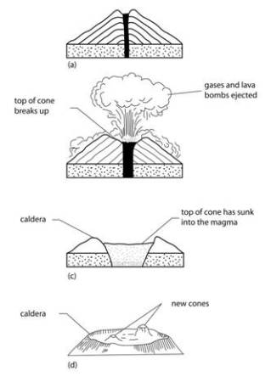

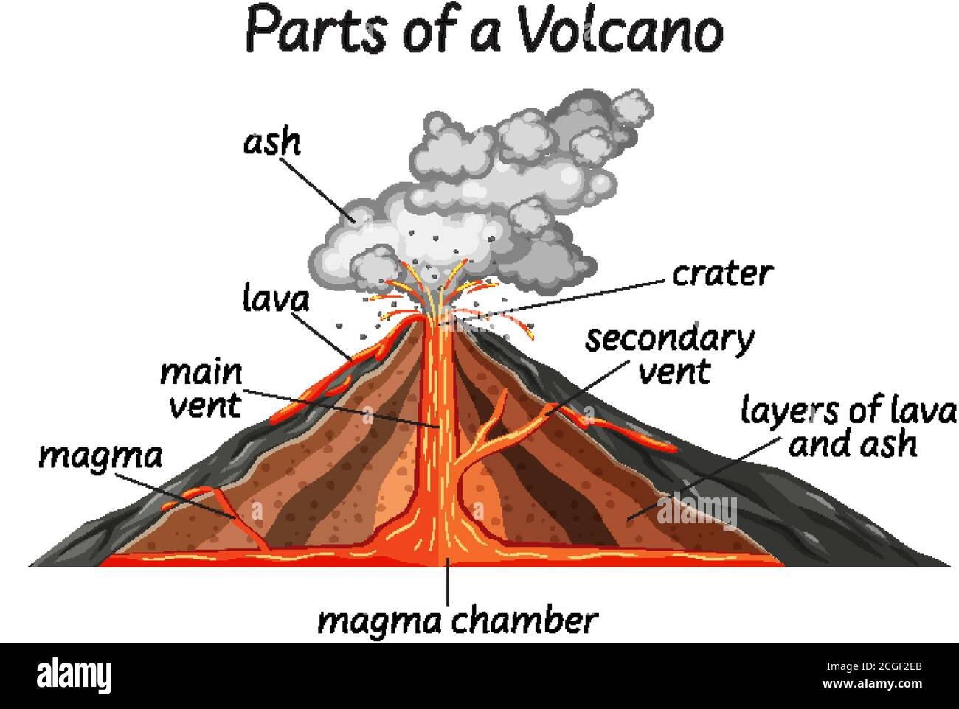

***Types of volcanic mountains***

***Active volcanoes***

* These are volcanic mountains which can erupt at any time.

***Examples***

* Mt. Mufumbiro
* Oldoinyo lengai

***Dormant volcanos / sleeping volcanoes***

These are mountains not erupted in the recent past but still show signs of erupting

***Examples***

* Mt. Moroto
* Mt. Longonot
* Mt. Meru

***Extinct volcanes/dead volcanos***

These are mountains that have stopped erupting

***Examples***

* Mt. Moroto
* Mt. Kenya
* Mt. Kilimanjaro

***Importance of volcanicity***

* It leads to formation of volcanic soil for crop growing
* Volcanic mountains formed by volcanicity are tourist attractions

***Dangers of volcanicity***

* It leads to destruction of property
* It leads to death of people and animals
* It leads to air pollution

***Other features formed as a result of volcanicity***

* Crater lakes
* Calderas
* Geysers
* Lava dammed lakes
* Hot springs

***Examples of hot springs***

* Kitagata hot spring (sheeema)
* Sempaya hot spring (Bundibugyo)
* Minera hot spring (Rukungiri)
* Kisizi hot spring (Rukungiri)

***Importance of hot springs***

* They are tourist attractions
* They are used to generate geo-thermal electricity

***Block mountain***

* They are also called horst mountains
* Block mountains were formed by the process of faulting
* Faulting is the cracking and breaking of rocks in the earth’s crust.
* A fault is a crack in the earth’s crust.
* Faulting is aided by compressional and tensional forces.
* Compressional force led to the formation of block mountains

***Diagram showing the formation of horst mountains***

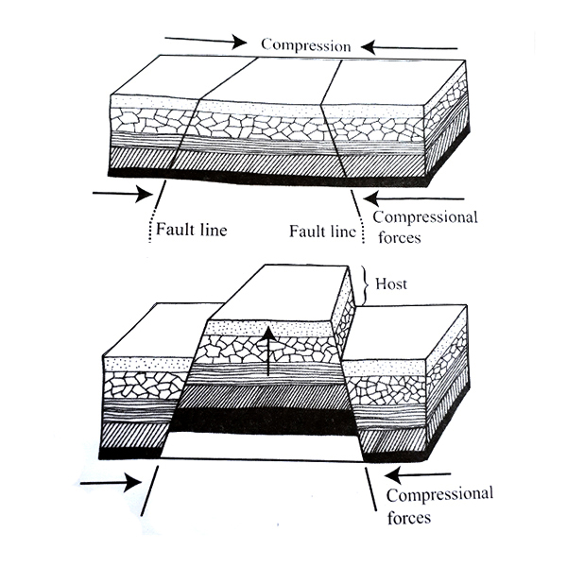

***Examples of block mountains***

* Mt. Rwenzori
* Mt. Usambara (TZ)
* Mt. Ulunguru (TZ)
* Mt. Pare (TZ)

***Highest peaks of major mountains in E.A***

|  |  |
| --- | --- |
| ***Mountain*** | ***Peak*** |
| Kilimanjaro  Kenya  Rwenzori  Elgon  Mufumbiro  Moroto | Kibo  Batian  Margherita  Wagagai  Muhavura  Sokolek |

***Snowcapped peaks in E.A***

* Batian
* Kibo
* Margherita

***Note***: The highest mountain in E.A is Kilimanjaro

***Importance of mountains***

* They help in rain formation
* They have fertile soils for crop growing
* Some mountains are sources of rivers
* Some mountains are sources of minerals
* Some mountains create boundaries between places
* Telecommunication masts are set up on mountains
* They attract tourists who bring income.

***Disadvantages of mountains***

* They hinder agricultural mechanization
* They make road and railway construction difficult
* Some mountains can erupt and kill people

***Map of E.A showing location of mountain***

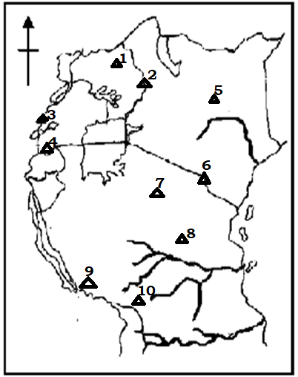

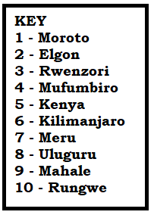

***Problems faced by people who live on slopes of mountains***

* Poor transport network
* Too much coldness
* Landslides
* Soil erosion

***Possible solutions***

* By constructing winding roads
* By wearing heavy clothes
* By planting trees to control landslides
* By terracing the land to control soil erosion
* By rearing animals like donkeys to help in transport.

***Activity***

1. Define the following terms;

Pastoralist

Nomad

1. In which way can pastoralists be helped to live a settled life?
2. How is the government of Uganda trying to control cattle rustling in Karamoja region?
3. How can the construction of valley dams help nomads to live a settled life?
4. Give two reasons why dairy farming is well developed in Kenya highland.
5. What is the industrial use of each of the following;

Hooves

Horn tips

1. Give another name for block mountains
2. Mention any two milk products
3. Name the forces that led to the formation of block mountains
4. What is sleeping volcanoes?
5. Why is peak Kibo snowcapped?
6. Compare Mt. Morotot and Mt. Uluguru in terms of formation.
7. Apart from attracting tourists, state any other way hot springs are economically important.
8. How can the problem of poor transport network be solved in hilly areas?
9. How do mountains hinder road transport?
10. Draw the following map symbol;
11. Mountain
12. Mountain peak
13. Hill
14. Why is there limited agricultural mechanization in Kabale district?
15. List down three mountainous districts in Uganda.

***Water as a resource***

* Rain is the main natural source of water in the environment.
* Drainage is the ground water system of an area.
* Drainage features are landforms that contain water.

***Examples of drainage features***

* Oceans
* Lakes
* Rivers
* Seas
* Streams

***Lakes in East Africa***

A lake is a depression on the earth’s surface filled with water.

***Types of lakes***

* Depression lakes
* Rift valley lakes
* Man made lakes
* Crater lakes
* Ox-bow lakes
* Lava dammed lakes
* Glacial lakes

***Depression lakes***

* They are also called basin/down warped lakes
* They were formed by the process of down warping

***Characteristics of basin lakes***

* They have fresh water because the have inlets and outlets
* They have irregular shapes
* They are shallow (because they are highly silted)
* They are wide

***Examples of basin lakes***

* L. Victoria
* L. Kyoga
* L. Bisina
* L. Wamala
* L. Goerge
* L. Kwania
* L. Amboseli
* L. Mburo
* L. Opeta

***Note***: L. Amboseli is the only fresh water lake in Kenya.

***Lake Victoria***

* Its local name in Uganda is Nalubale (home of gods), Kenya is Sango and Tanzania Nyanza
* It was formed by down warping
* It is the largest fresh water lake in E.A
* It is called an inter-territorial lake because it is shared by three countries
* John Speke was the first white man to see L. Victoria and named it after queen Victoria of England.
* Kalangala and Buvuma districts are completely surrounded by L. Victoria
* It has inland ports that handle goods of E.A countries.

***Inland ports on L. Victoria***

|  |  |  |
| --- | --- | --- |
| ***Uganda*** | ***Kenya*** | ***Tanzania*** |
| Port Bell  Port Jinja  Port Bukakata | Port Kisumu  Port Homa Bay | Port Mwanza  Port Musoma  Port Bukoba |

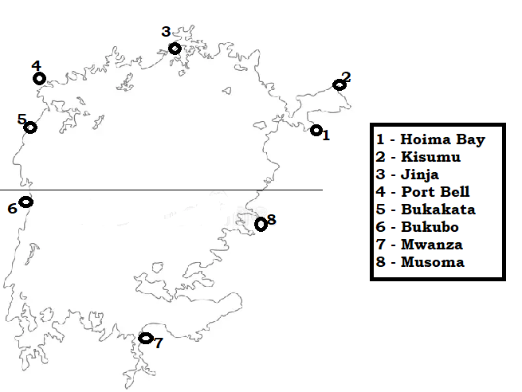

***Rivers that flow into L . Victoria***

* R. Kagera
* R. Katonga
* R. Nzoia
* R. Yala

***L. Kyoga***

* It was formed by down warping
* It is the shallowest lake because it is highly silted by the Nile.
* It is the swampiest lake because it is shallow.
* R. Nile flows from L. Victoria / towards L. Kyoga
* Inland ports on L.Kyoga are Port Lwampanga, Port Namasale and Port Masindi
* Rivers that flow into L. Kyoga are R. Nile, R. Mpologoma and R. Sezibwa

***Rift valley lakes***

* They are found at the floor of the rift valley
* They were formed by faulting
* They are also called fault lakes

***Characteristics of rift valley lakes***

* They are long and narrow (oblong)
* They have salty water because they lack outlets
* They are deep

***Why rift valley lakes have salty water***

* They lack outlets
* They have salty rocks beneath

***Examples of rift valley lakes***

|  |  |
| --- | --- |
| ***Western arm***  L. Albert  L. Edward  L. Tanganyika  L. Kivu  L. Rukwa | ***Eastern arm***  L. Turkana  L. Natron  L. Magadi  L. Nakuru  L. Baringo  L. Manyara  L. Eyasi  L. Bogoria |

***Note***: Butiaba escarpment in Uganda is the major escarpment of the western rift valley.

* Mau escarpment in Kenya is the main escarpment of the Eastern rift valley

***Lake Tanganyika***

* It is the longest and deepest lake in E.A.
* It forms a natural boundary between Tanzania, and Zambia, Tanzania and RDC, Burundi and DRC.
* Port Kigoma is the main inland port on L. Tanganyika

***Lake Turkana***

* It was formerly known as L. Rudolf
* It forms a boundary between Kenya and Ethiopia
* It was named Turkana by Jomo Kenyatta after the Turkana tribe that lives near L. Turkana

**Note**: L. Kivu is the major rift valley lake in Rwanda.

* L. Nakuru is a rift valley lake commonly referred to as a birds’ sanctuary.
* Lake Magadi is a rift valley in Kenya famous for salt and soda as mining.

Detailed information about L. Albert, L. Edward, and L. George refer to P.5 work

***Crater lakes and caldera lakes***

* They are found on top of volcanic mountains
* They are formed as a result of volatility
* They are formed when water collects in a carter
* ***A crater*** is a hole on top of a volcano after an eruption
* ***A caldera*** is a large round depression found on top of a volcanic mountain.
* Caldera lakes are formed when water collects in a caldera.
* Most crater lakes in Uganda are found in South western part because this area experienced volcanicity for a long time.

***Examples of crater lakes***

* L. Katwe
* L. Nyamunuka
* L. Nyakasura
* L. Ngorongoro
* Mt. Elgon Crater Lake

***Note***: L. Katwe is the crater lake found in the rift valley.

***Ox*-bow lakes**

* These are formed as a result of river meandering and deposition.
* They are commonly formed on meandering rivers at the old stage.

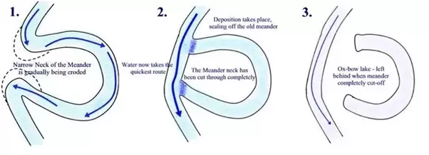

* Ox bow lakes are commonly found on River Kilombero

***Lava dammed lakes***

* They are formed when flowing lava blocks the valley of a flowing river.
* They are formed by the process of volcanicity

***Examples of lava dammed lakes***

* L. Bunyonyi
* L. Bulera
* L. Rutoto
* L. Mutanda

***Note***: Lake Bunyonyi is the deepest lake in Uganda.

***Manmade lakes***

* They are formed as a result of man’s activities
* They can be formed as a result of dam construction
* They can also be dug

***Man made lakes that were dug***

* Kabaka’s Lake
* Kibimba Lake
* Uganda Martyrs’ Lake Namugongo

***Man made lakes formed as a result of dam construction***

* L . Kindaruma
* Lake Nyumba ya mungu on R. Pangani

***Map of E.A showing major lakes***

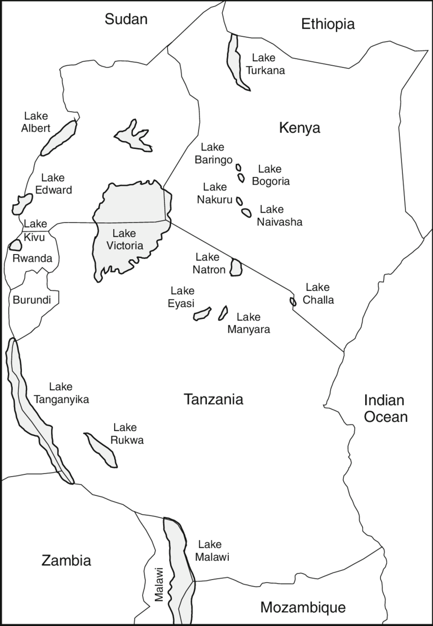

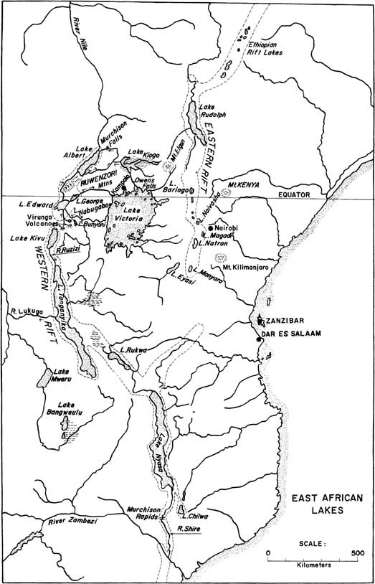

***Activity***

1. State any two types of lakes
2. Draw a map symbol for;
3. Permanent lakes
4. Seasonal lakes
5. Why are basin lakes usually shallow?
6. Give one example of a fresh water lake in Kenya
7. Compare Lake Kivu and L. Katwe in terms of formation.
8. Of what political importance are lakes in E.A?
9. Why do most rift valley lakes have salty water?
10. Why is L. Albert which is a rift valley lake has fresh water?
11. Name the deepest lake in;

Uganda

East Africa

1. State any one example of crater lake found in the rift valley
2. How are inland ports important in the country?
3. Apart from Butiaba escarpment, give any one other example of an escarpment in E.A.
4. Name the major inland port on L. Tanganyika
5. Which arm of the rift valley passes through Uganda?
6. What process led to the formation of the rift valley?
7. What type of lakes are commonly found along meandering rivers?

***Major rivers of E.A***

* A river is a mass of water flowing in a channel on the earth’s surface
* Rivers flow high altitude to altitude
* Most rivers in East Africa originate from highland areas

***Why most rivers originate from highlands***

* Highland areas receive heavy rainfall
* Some mountains have snow which melts to for rivers

***Types of rivers***

* Permanent rivers
* Seasonal rivers

***Note***: Seasonal rivers flow during the wet season and dry up during the dry season e.g R.Lagh Bor and R. Lagh

* Permanent rivers flow throughout the year.

***Examples of permanent rivers***

|  |  |  |
| --- | --- | --- |
| ***Uganda*** | ***Kenya*** | ***Tanzania*** |
| R. Nile  R. Kagera  R. Katonga  R. Mpologoma  R. Achwa  R. Kafu  R. Semliki  R. Sezibwa  R. Manafwa | R. Tana  R. Athi  R. Nzoia  R. Ghana  R. Yala  R. Mara | R. Rufiiji  R. Pangani  R. Ruvuma  R. Wami  R. Kagera  R. Rungwa |

***Terms related to rivers***

***River source*** – is a point where a river starts to flow.

***River mouth*** – is a point where a river end to flow

***A tributary*** – is a small river that joins the main river

***A distributary*** – is a small river that branches away from the main river

***A river confluence*** – is a meting point for two or more rivers

***An estuary*** – is a wide mouth of a river

***A delta*** – is place where a river forms distributaries at its mouth (R. Nile, Semliki)

***A river meander*** – is a bend of a river

***A gorge*** – is a v – shaped valley of a river.

***A drainage basin*** – is an area drained by a river, its tributaries and distributaries

***A flood plain*** – is a flat area near the river that often floods when the water level rises.

***A cataract*** – is a series of waterfalls.

***Stages of a river***

* Youth stage
* Mature stage
* Old stage

***Youth stage // upper course***

* It is found at the river source
* It has waterfalls
* Th river flow very fast
* It forms v – shaped valleys (gorges)

***Note***: This stage is suitable for the generation of HEP and tourism because it has many waterfalls

***Mature/middle stage***

* The river flows gently
* It forms u-shaped valleys
* Meanders begin to occur

***Old stage/lower course***

* The river flows slowly
* It has well developed meanders
* Ox-bow lakes, estuaries, deltas, flood plains are common features found at this stage

***Features found along river valleys***

* Waterfalls
* Ox-bow lakes
* Gorges
* Deltas
* Estuaries

***River Nile***

* This is the longest river in Uganda, E.A, Africa and in the world
* Its local name is Omugga Kiira
* Its source is L. Victoria
* Its mouth is the Mediterranean Sea in Egypt
* John Speke was the first white man to see the source of R. Nile
* River Nile flow north wards because the plateau on which it flows is tilted North.

***Countries through which R. Nile flows***

* Uganda
* South Sudan
* Sudan
* Egypt

***Sections of R. Nile***

* Victoria Nile from L. Victoria to L. Albert
* Albert Nile from L. Albert to Nimule
* White Nile from Nimule to Sudan

***Tributaries of R. Nile in E.A***

* River Achwa

***Waterfalls on the Nile***

* Kalagala falls
* Murchsion falls
* Karuma falls
* Itanda falls

***Dams on R. Nile***

* Nalubaale dam
* Bujagali dam
* Isimba dam
* Kira dam
* Karuma dam

***Nile valley***

* This is an area drained by River Nile and its tributaries

***Examples of Nile valley countries***

* Uganda
* Ethiopia
* South Sudan
* Sudan
* Egypt

***Reasons why some parts of rivers are not navigable***

* They have water falls
* They are shallow
* They are narrow
* They have dams

***River Tana***

* It is the longest and largest river in Kenya
* It flows into the India Ocean
* The seven Forks Dam project was set up on R. Tana in Kenya

***Power dams built along R. Tana***

* Giatru Dam
* Inolaruma Dam
* Kamburu Dam
* Kiambere Dam

***Rive Ruvuma***

* It forms a boundary between Tanzania and Mozambique
* It pours in to the Indian Ocean

***Detailed information about R. Kagra, R. Katonga R. Semliki, R. Achwa refer to P.5 work***

**Note**: Many rivers in E.A flow into the Indian Ocean because the Indian Ocan is at a lower altitude

Rivers that flow into the Indian Ocean are R. Tana. R. Rufugu, R. Pangani, R. Wami, R. Galana, R. Ruvuma etc

***Economic activities favored by lakes and rivers***

* Fishing
* Crop growing
* Tourism
* Transportation
* Industralisation

***Importance of lakes and rivers***

* They help in rain formation
* They act as fishing grounds
* They are homes of aquatic life
* They form boundaries between places
* They provide water for irrigation
* They provide water for industrial use
* They provide water for domestic use
* They are used for water transport

***Problems associated with water bodies***

* Drowning
* Flooding
* They harbor disease vectors
* They harbor dangerous aquatic animals
* Rivers and lakes hinder road construction

***Problems faced by water bodies***

* Silting which reduced the depths of water bodies
* Drought which reduces water levels
* Pollution of water bodies

***Revision about fishing (Refer to P.5 work)***

***Activity***

1. Draw the following map symbols
2. Water fall
3. Dam
4. Permanent river
5. Seasonal river
6. Why does R. Nile flow North wards?
7. What stage does R. Nile flow North wards?
8. What stage of a river is commonly associated by V -shaped valleys?
9. Why is the youth stage of a river suitable or generation of H.E.P?
10. Which river creates boundary between;
11. Uganda and DRC
12. Uganda and Tanzania
13. Tanzania and Mozambique
14. Name the lake that creates a boundary between
15. Uganda and DRC
16. Kenya and Ethiopia
17. Tanzania and DRC
18. Tanzania and Malawi
19. State any two economic importance of R. Tana to the Kenyans
20. How do lakes and river promote crop farming?
21. State any two modern methods of catching fish.
22. State any two traditional/local methods of preserving fish
23. Point out any two problems facing the fishing industry
24. How does the water hyacinth affect the fishing industry?
25. Which type of rainfall is commonly received near large lakes and rivers?
26. How can road transport be made possible across rivers?

***People as a resource***

Human resource are people who provide labour to exploit resources

***Types of labour***

***Skilled labour*** – these are people who are trained to do different pieces of work e.g teachers, doctors, lawyers etc

***Unskilled labour*** – these are people who are not trained but help to do work eg porters, shamba boys etc

***Importance pf people as a resource***

* They provide market for goods
* They provide labour
* They train labour
* They pay taxes

***Problems facing human resources***

* Poor pay
* Poor working conditions
* Unemployment

***Ways of improving labour***

* Paying labour well
* Training labour
* Improving the working conditions

***Topic: transport and communication in E.A***

***Sub topic: Transport in E.A***

***Transport*** is the movement of people or goods from one place to another.

Transport is Uganda is under the Ministry of Works and Transport

***Uganda National Roads Authority*** (UNRA) is the body responsible for building and maintaining major roads

***Factors considered when choosing the means of transport***

* Distance to be covered
* Type of good
* Transport fare
* Comfort

***Types of transport***

* Road transport
* Water transport
* Pipeline transport
* Railway transport
* Air transport

***Road transport***

This is the movement of people or goods from one place to another on the road.

***A road*** is a hard surface where vehicle move.

Means of road transport (traditional)

* Human portage
* Pack animals (donkeys, horses, camels)
* Carts

***Modern means of road transport***

* Buses
* Bicycles
* Cars
* Lorries
* Motorcycles

***Types of roads***

* Murram roads
* Tarmac roads

***Murram roads***

* They are made of soil and gravel
* They are commonly found in rural areas
* They are sometimes called seasonal roads
* They are dusty during the dry season and muddy and slippery during rainy season.

***Tarmac roads***

* They are sometimes called all weather roads
* They are made of tar and gravel
* They are commonly found in urban centres and developed countries

***Note***:

* Feeder road are small roads that join major roads
* They are either murram or tarmac roads
* They help farmers to transport their produce

***Major roads that cross E.A***

***Trans – African Highway*** – starts from Mombasa, Uganda, DRC, Central African Republic, Cameroon and end in Lagos in Nigeria

***The Great North Road*** – starts from Cape Town in South Africa, Bostwana, Zimbabwe, Zambia, Tanzania, Kenya, Uganda, South Sudan, Sudan and ends in Egypt.

***Importance of having a well-developed road transport network***

* It promotes trade
* It promotes tourism
* It promotes industrialization
* It makes administration easy
* It makes exploitation of resources easy
* It promotes urbanization

***Advantages of road transport***

* It is cheap for short distance
* It is flexible
* It is the commonest
* Roads are cheap to construct
* It takes people and goods to their final destination

***Disadvantages***

* It is affected by traffic jam
* Accidents are very common
* Roads require regular maintenance

***Problems faced when using road transport***

* Accidents
* Traffic jam
* Bad weather

***Examples of road users***

* Pedestrians
* Riders
* Drivers
* Cyclists

***Causes of road accidents***

* Speeding of vehicles
* Overloading of vehicles
* Driving vehicles in dangerous mechanical conditions
* Poor roads
* Driving under the influence of alcohol and drugs

***Ways of controlling / reducing road accidents***

* Teaching people road safety rules
* Putting road signs along roads
* Fixing speed governors in vehicles
* Repairing poor roads
* Constructing wide roads

***Road signs – Refer to P.4 and P.5 work***

***Water transport***

* This is the movement of people or goods from one place to another on water.
* This is the cheapest and slowest type of transport
* It is suitable for carrying bulky and fragile goods
* A port is a place where water vessels load and unload goods.
* An inland port is a port found on a lake or a river.
* Sea port is a port found on a sea or ocean.
* Navigation is movement on water
* A hinterland is an area served by a sea port

***Sea ports that handle goods in E.A***

* Port Mombasa
* Port Dar-es-salaam

***Hinterlands of Port Mombasa***

* Kenya
* DRC
* Tanzania
* South Sudan
* Uganda
* Rwanda
* Burundi

***Importance of Port Mombasa to Kenya***

* It handles Kenya’s
* It is a source of employment
* It is a source of revenue by taxing countries that use Port Mombasa

***Importance of Port Mombasa to countries of E.A***

* It handles goods of countries of E.A

***Why most Ugandans use Port Mombasa***

* Port Mombasa is nearer to Uganda

***Imports***

These are goods bought from other countries

***Examples of major imports of E.A***

* Vehicles
* Drugs
* Electronics
* Machinery
* Petroleum products

***Exports***

These are goods sold to other countries

***Examples of E. A’s exports***

* Minerals
* Fish
* Tourism
* Agricultural products

***Traditional means of water transport***

* Canoes
* Dhows
* Rafts
* Stepping stones

***Modern means of water transport***

* Ships
* Boats
* Ferries

***Advantages of water transport***

* It is not affected by traffic jam
* It is good for transporting bulky goods
* It is good for transporting fragile goods
* It is very cheap

***Disadvantages of water transport***

* It is very slow
* It is affected by storms
* It is not flexible
* It does not take people and goods to the final destination

***Causes of accident on water***

* Overloading of water vessels
* Water vessels in poor mechanical conditions
* Presence of dangerous water animals
* Storms that make water vessels capsize

***Air transport***

* This is the fastest and most expensive type of transport.
* Air transport in E.A was controlled by the East African Airways
* The first aero plane landed at Entebbe in 1927.
* Civil Aviation Authority (CAA) is the body responsible for managing air transport services in Uganda.

***Means of air transport***

* Aeroplane
* Helicopters
* Hot air balloons
* Rockets
* Parachutes
* Jets

***Places where aircrafts can land and take off***

***Airport*** – this is a large area where aeroplanes land and take off.

***Airstrips*** – a narrow strip of land where aircrafts can land and take off e.g Kololo airstrip, Mbale airstrip.

***Airfield*** – is an area of flat ground where private planes can land and take off.

***Examples of international airports in E.A***

* Uganda – Entebbe airport
* Kenya – Nairobi International Airport, Mombasa Airport, Eldoret Airport, Kisumu Airport
* Tanzania – Dar-es-salaam airport, Kilimanjaro Airport, Arusha airport
* Rwanda – Kigali International Airport
* Burundi – Bujumbura International Airport

***Air transport companies in E.A***

* Ethiopian Airlines
* Emirates Airlines
* Air Tanzania
* British Airways
* Turkish Airways
* Kenya Airways
* Qatar Airways
* Air France
* South African Airways
* Air Uganda

***Note***: Air transport uses direct routes unlike other types of transport that are sometimes affected by physical features

***Advantages of air transport***

* It is the fastest type of transport
* It connects different regions of the world
* It is reliable since it follows a time table
* It is suitable for transporting perishable goods
* It is not affected by traffic jam

***Disadvantages of air transport***

* It is the most expensive type of transport
* Airports are very expensive to construct and maintain
* It does not take goods to the final destination
* In case of an accident, chances of serving are minimal

***Note***: We have the following types of goods

***Fragile goods*** – these are goods that can easily break/get spoilt. e.g eggs, glass

***Perishable goods*** – these are goods that can easily go bad e.g fresh milk, fresh flowers, fresh fish, fresh meat etc

***Bulky goods*** – these re goods that are heavy and take a lot of space during transportation

There are two categories of the means of transporting

Passenger means of transport carry people

Cargo means of transport carry goods

***Pipeline transport***

* This is the best type of transport for transporting liquids and gases.
* A pipeline is a series of pipes used for transporting liquids and gases
* Pipeline transport is the movement of goods from one place to another through pipes.
* The first pipeline in E.A was built by the Italians for Dra-es-Salaam to Zambia
* The pipelines in Kenya were built by the Japanese from Mombasa to Nairobi, Kisumu and Eldoret
* Uganda is building a pipeline for transporting petroleum from the Albertine region to Tanga port in Tanzania for refining and exploration

***Items transport by pipelines***

* petroleum
* water
* sewage
* gas

***Advantages of pipeline transport***

* it delivers goods to the final destination
* It does not pollute the environment
* It is not affected by traffic jam
* It is quicker in transporting liquids

***Disadvantages of pipeline transport***

* Pipes are expensive to buy and install
* Pipelines are costly to repair
* There is a great loss in case of leakages

***Railway transport***

***A railway*** is a track with rails on which trains move.

***Railway transport*** is the movement of people or goods by trains.

* The first railway line in Tanzania.
* It was built by the Germans mainly to transport sisal.

***Means of railway transport***

* Trains
* Trams

***Types of trains***

* Passenger trains – carry people
* Cargo trains – carry goods

***Disadvantages of railway transport***

* Railway lines are expensive to construct
* It does not take people and goods to the final destination
* It is difficult to construct in hilly areas.

***Major railway lines in E.A***

* Tanga – Korogwe railway line
* Kenya – Uganda railway line
* Tazara / Tanzam railway line
* The Central railway line of Tanganyika

***Tazara railway line***

* It stands for Tanzania – Zambia Railway
* It is also called Tanzam railway line
* It was constructed by the Chinese
* The construction as funded by the government of Tanzania and Zambia from 1970 – 1975.

Why it was constructed

* To transport copper ore from Zambia copper belt to Dar-es-Salaam for export.
* To link Zambia to Port Dar-es-salaam

***The Kenya – Uganda railway***

* It is also called the Uganda railway because it was mainly built to link Uganda to the coast of E.A
* The idea of building the Uganda Railway was brought by Sir William Mackinnon.
* It was constructed by the British government
* The construction of the Uganda Railway started at Mombasa in 1896 and ended at Pakwach in 1965
* The African natives first provided labour during the construction of the Uganda Railway but later refused
* The Indian coolies were hired to replace the Africans

***Reasons why Africans refused to provide labour during the construction of the Uganda railway***

* They did not want to leave their families for a long time
* They were under paid
* They feared man eaters

***Reasons for the construction of the Uganda Railway***

* To link Uganda to the E.A coast
* To stop slave trade
* To make administration easy
* To make transport easy
* To encourage white settlement in Kenya

***Reasons why the Kenya – Uganda railway was extended to different places***

* Pakwach – to transport tobacco from West Nile
* Namasagali – to transport cotton
* Kasese – to transport copper ore to Jinja for smelting
* Tororo – to transport limestone to the E.A coast
* Port Bell – to transport goods from and to L. Victoria

***Problems faced during the construction of the Uganda railway***

* Attacks from man eaters
* Attacks from hostile people eg Nandi, Masai
* Attacks from tropical diseases
* Shortage of labour
* Constructing the railway across escarpments was difficult

***Note***:

* The problem of shortage of labour was solved by hiring the Indian coolies
* The problem of man eaters was solved by Colonel Patterson killing the fierce lions

***Roles played by different personalities towards the construction of the Uganda railway***

* Sir William Mackinnon – he brought the idea of building the Uganda railway
* Captain Mac Donald - he surveyed the land where the Uganda railway was to pass
* George Whitehouse – he was the chief engineer during the construction
* Colonel Patterson – he killed the force lions at Tsavo
* Guildford Molesworth – he made the final inspection of the completed railway line

***Effects of the construction of Uganda railway***

***Positive***

* Slave trade was stopped
* It led the development of town along the railway line
* It made transport easier
* British administration became easy

***Negative effects***

* It led to the coming of the white settlers in Kenya
* It led to increased exploitation of E. A’s resources

***Note:***

* The humanitarian reason for construction of the Uganda Railway was need to stop slave trade.
* The construction of the Uganda railway helped to stop slave trade in a way that trains were used to transport goods instead of slaves

***Map showing major railway lines in E.A***

***Activity***

1. In which way can roads promote trade?
2. State any two advantages of road transport over air transport
3. State two advantages of road transport over air transport
4. Name the body responsible for constructing major roads in Uganda
5. What role is played by CAA in Uganda
6. How is Port Mombasa economically important to Rwanda?
7. What are exports?
8. Mention any three exports of Uganda
9. Why does the distance from Kabale to Gulu appear shorter by plane than by bus?
10. What are cargo planes?
11. Why is a person transporting fresh fish from Uganda to USA advised to use air transport not any other type of transport?
12. Why was the Kenya-Uganda railway called the Uganda Railway?
13. Name the coastal town where the construction of the Uganda Railway started.
14. Write brief notes about the following personalities;
15. Sir Guildford Molesworth
16. Colonel Patterson
17. How did the construction of the Uganda Railway help to end slave trade?
18. How was the problem of shortage f labor solved during the building of the Uganda Railway?
19. What problem was faced by the builders of the Uganda Railway at Voi?
20. Which ministry in Uganda is in charge of transport?
21. State any one negative result of the construction o the Uganda Railway.

***Communication in E.A***

Communication is the sending and receiving of messages.

***Types of communication***

* Verbal communication
* Nonverbal communication

***Types of means of communication***

* Traditional means of communication
* Modern means of communication

***Examples of traditional means of communication***

* Bell
* Whistle
* Drum
* Smoke signal
* Clapping

***Uses of drums***

* For communication
* For entertainment
* They represent culture

***Materials used to make drums***

* Skins and hides
* Wood
* Metal

***Challenges of traditional means of communication***

* They are slow in delivering information
* They require a lot of effort to use e.g blowing trumpets
* They have a small coverage

***Advantages of traditional means***

* It is cheap to get information
* They favour both the illiterate and literates

***Modern means of communications***

* Telephones
* Newspapers
* Radios
* Bill boards
* E – mails
* Magazines
* Letters
* Televisions

***Advantages of modern means of communication***

* They have a wider coverage
* They are fast at delivering information
* They are not tiresome to use

***Disadvantages of modern means of communication***

* They are expensive to buy
* They are complicated to use
* Some modern means do not favour the illiterates
* Some promote immorality

***Importance of communication***

* It promotes unity among different people
* It promotes trade
* It promotes security

***How communication promotes trade***

* It helps to advertise goods
* It helps people to know the prices of goods
* It keeps buyers and sellers in touch

***Note***:

* Uganda Communications Commissions is in charge of communication in Uganda
* UCC gives license to communication companies to operate in Uganda

***Forms of modern communication***

* Mass media communication
* Tele-communication e.g use of telephones, telefax, radio calls etc

***Mass media means of communication***

* Mass media are means of communication that send information to many people at the same time

***Examples of mass media means of communication***

* Radios
* Televisions
* Magazines
* Bill boards
* Newspapers
* Notice boards
* Neon signs

***Categories of mass media of communication***

* Print media
* Electronic media

***Print media***

* Information is sent to people through printed materials e.g newspapers, magazines, newsletters, noticeboards

***Electronic media***

* These are means of communication that operate by the help of electricity. e.g radio, televisions, neon signs.

***Radio communication***

* A radio is a piece of equipment for listening to programmes, advertisements, music etc
* A radio station is a place where radio programmes are broadcast
* Radios only provide audio information
* Radios are the most widely used means of communication

***Government owned radio stations in Uganda***

* Uganda Broadcasting Corporation (UBC)
* Bukedde FM
* Magic FM
* Star FM

***Privately owned radio stations***

* Top radio
* Simba FM
* Ddembe FM
* Capital FM
* Beat FM
* Super FM

***Note***: FM in full is frequency Modulation

***Reasons why radios are widely used***

* They are cheap to buy
* Radio programmes are broadcast in many languages

***Advantages of radio communication***

* Radios have a wider coverage
* Radios are cheap to buy
* They favour both the blind and illiterates
* They broadcast educative programmes

Disadvantages of radio communication

* It does not cater for the deaf
* Some radio programmes promote immorality
* It is costly to buy dry cells

***Newspapers***

* These are large printed sheets of paper containing news, articles, advertisement etc that are printed daily or weekly

***Government owned newspapers in Uganda***

* The New Vision
* Etop
* Orumuri
* Rupiny
* Bukedde

***Private owned newspapers***

* Daily monitor
* Red pepper
* Observer
* Kamunye

***Newspapers published in local languages***

* Etop
* Rupiny
* Orumuri
* Bukedde

***Advantages of newspapers***

* They provide detailed information
* The information in newspapers can be stored for future use
* They cater for the deaf and dumb
* They entertain people through cartoons and stories

***Disadvantages***

* They are expensive to buy daily
* They take long to reach remote places
* They do not favour illiterates
* Some newspapers show pornographic pictures

***Roles played by newspapers in the development of a country***

* They advertise goods
* They create employment
* Newspaper companies pay taxes to the government

***Television communication***

* A television is a piece of equipment with a screen on which people watch programmes with moving pictures and sound.
* Television communication is audio-visual i.e one watches and hears at the same time.

***Examples of television stations***

|  |  |
| --- | --- |
| ***Government owned*** | ***Private*** |
| UBC TV  Star TV  Urban TV  Bukedde TV  TV West | National Television (NTV)  Top TV  NBS TV  Salt TV  KTV  Spark TV |

***Advantages of television communication***

* It is audio visula
* It caters for the deaf and dumb
* Televisions broadcast educative programmes

***Disadvantages***

* Televisions are expensive to buy
* They are only used where there is electricity
* Some televisions programmes promote immorality

***Telephone communication***

This is the quickest means of communication in E.A

***Telecommunication companies in E.A***

* This is the quickest means of communication in E.A

***Telecommunication companies in E.A***

|  |  |
| --- | --- |
| ***Country*** | ***Telecommunication companies*** |
| Uganda | Mobile telephone Network (MTN), Lycamobile, K2 Telecom, Airtel Uganda |
| Kenya | Safari com., Airtel, Africel, Essar telecom |
| Tanzania | Vodacom, Airtel, Tigo, Safaricom |
| Rwanda | Tigo, Rwandatel |
| Burundi | U.com, Tempo |

***Mobile telephone companies***

* Techno
* Itel
* Nokia
* Samsung
* Alcatel
* Huawei
* Motorola

***Advantages of telephone communication***

* It covers a wider coverage
* Telephones are quick at sending information
* Telephone communication provides instant feedback

***Disadvantages of telephone communication***

* Telephones are expensive to buy
* Telephones need regular loading of airtime
* Telephones require regular charging to be used
* Communication is impossible where there is no network

***Importance of mobile phones***

* They are used for communication
* They are used to send and receive money
* They are used to store money
* They are used to advertise goods

***Note***: Telecommunication companies set up masts on hills/mountains to tap networks

***The post office***

* This is an organization responsible for collecting and delivering letters and parcels
* A post office box is a lockable box an address at a post office that is used as a collection point for mails
* The biggest post office in Uganda is found in Kampala
* Postal services enable us to send letters and parcels with in a country or outside the country

***Government companies that carry out postal services***

* Uganda – Posta Uganda
* Kenya – Posta Corporation of Kenya
* Tanzania – Tanzania Posts and Corporation

***Social services offered by the post office***

* Communication service
* Transport service
* Banking service

***Private companies which deliver mails or parcels (courier companies)***

* Daks Courier Limited
* Skynet Worldwide Express
* DHL International

***Importance of the Post Office***

* It sends letters and parcels to the owners
* It sells stamps
* It provides employment
* It provides transport services
* It offers banking services

***Problems facing the Post Office***

* Poor transport and communication
* Competition from other communication sectors e.g using internet
* Lack of funds to boast the postal services

***Communication barriers/Problems facing communication***

* Shortage of funds
* Limited skilled labour force
* Low levels of technology
* Poverty among people
* Poor transport network
* High levels of illiteracy

***Possible solutions***

* By introducing a national language
* Building better transport lines
* Availing means of communication to people at low costs
* By building communication masts to boost network

***Note***:

* A national language is a local language spoken by most people in the country
* Kenya and Tanzania have Swahili as their national language
* Rwanda has Kinyarwanda as the National Language
* Burundi has Kirundi as the National language
* Uganda does not have a national language because;

It has many tribes that speak many local languages

It lacks a language policy

***Importance of national language***

* It promotes unity
* It promotes trade
* It makes communication easy

|  |  |  |
| --- | --- | --- |
| ***Country*** | ***Official language*** | ***National language*** |
| Uganda  Kenya  Tanzania  Rwanda  Burundi | English  English  English  French  French | -  Kiswahili  Kiswahili  Kinyarwanda  Kirundi |

* An official language is a language accepted to be used in all public places in the country.
* Uganda uses English as its official language because it was colonized by an English-speaking country.
* Rwanda uses French as its official language because Rwanda was granted independence by the French speaking country.

**Activity**

1. Point out two examples of traditional means of communication.
2. Point out two modern means of communication
3. Write down any one role played by UCC in Uganda.
4. How do newspapers promote trade?
5. How are hills important to telecommunication companies?
6. In which one way is radio communication better than television communication?
7. Give one reason why radios are widely used as a means of communication
8. Why are newspapers not widely used as a means of communication in rural areas?
9. State any two social services provided by the Post Office.
10. Mention any two newspapers in Uganda polished in local languages
11. State any two disadvantages of telephone communication
12. List down any two telecommunication companies operating in Uganda
13. Why does Uganda have a national language?
14. In which two ways is a national language important?
15. Why does Rwanda use French as her official language?
16. State any two communication barriers in Uganda
17. Name the National language of Tanzania